f | استمارة تقييم بحث طلابي | 
كلية الحاسبات والذكاء الاصطناعي | الفصل الدراسي الثاني للعام الجامعي 2019/2020 | جامعة بنهـــــا

أولا بيانات الطالب (تملأ بمعرفة الطالب)
اسم الطالب : محمود رضا حسنين محمودالطباخ رقم الجلوس:1429
البريد الإلكتروني الأكاديمي: mahmoud192536@fci.bu.edu.eg
اسم البرنامج الدراسي/ القسم: عام
المستوى/الفرقة: الاولي
ثانيا بيانات البحث (تملأ بمعرفة الطالب)
اسم المقرر: Electronics
اسم أستاذ المقرر: Dr. Tamer Ahmed Abassy
عنوان موضوع البحث: Ideal Basic Circuit Elements
رقم الموضوع (إن وجد)Topic No.1
ثالثا تقييم البحث بمعرفة لجنة الممتحنين
هل البحث منقول؟ □ نعم □ لا
في حالة ان الإجابة بنعم لا يتم تقييم البحث ويعتبر تقييم الطالب في البحث لم يجتاز
م | عناصر التقييم | الوزن النسبي | مقبول | غير مقبول
1 | الشكل العام للرسالة البحثية | 10
2 | يحقق المتطلبات العلمية المطلوبة | 70
3 | يذكر المصادر والمراجع العلمية | 10
4 | الصياغة اللغوية واسلوب الكتابة جيد | 10
رابعا نتيجة التقييم النهائي
اجتاز | لم يجتاز | توقيع لجنة التقييم
- ...........................................................
- ...........................................................
- ...........................................................
** يرجى التأكد من الا تزيد هذه الاستمارة بعد استكمال البيانات عن صفحة واحدة فقط
f |  | 
Benha University |  | Faculty of Computers & Artificial Intelligence

Research Project Title

A research project submitted
in partial fulfillment of the requirements for passing
the 2nd semester 2020 evaluation

In
Electronics

by
Mahmoud Reda Hussanin Mahmoud El Tabakh(429)

Supervised by
Dr. Tamer Ahmed Abassy

June 2020

1. Introduction ( Electricity and electronics in our life )
Using electronics today is so much a part of our daily lives we hardly think of the way the world would be without electronics. Wireless internet is becoming more common all the time, The computer user can do all the web searching in relative privacy thanks to the electronic accessories which can be added to the computer. Conversely, more and more transactions are being sent electronically across the airwaves so security is becoming a larger issue than ever before. Literally thousands of everyday devices that we use constantly make use of electronics technology in order to operate. These are products ranging from automotive engines to automated equipment in production settings. Even artistic efforts benefit from computer modeling prior to the committing of valuable artistic media to create the finished product. Many of us may fail to realize the important role that electronics play in our daily lives. In fact, the invention of such electronic gadgets has somehow made our lives easier. It is just that with us being very busy going through the day with a lot of things on our mind and with work to take care of, we often fail to take notice and appreciate how convenient everything has become because of these consumer electronic goods space most importantly. Quite often we only realize their value in our lives when an electronic gadget gets damaged or when we experience a power failure for some time when everything seems to set in that without electricity and these gadgets we cannot do anything at all. As more and more current inventions and electronic gadgets are flooding the market, each and everyone should learn to appreciate the convenience that these have offered to our daily lives. Who knows what they would think of next in the near future. While having the latest and greatest electronic devices can be fun, necessary, or both, our addiction to having them comes at a high cost to ourselves and our planet. Enormous amounts of raw, often limited, resources are used to make these devices. Electronics is widely used in information processing, communication and signal processing. Electronics is the art of controlling the movement of electrons in order to design components and circuits that are put together to create the technology of the modern world. Increasingly electronics is at the cutting edge of technology, Electronics covers the physics, engineering, technology and applications that deal with the emission, flow and control of electrons in vacuum and matter. Electrification did not become an essential part of our daily life, except when scientists came to how to control the movement of free electrical charges present in the materials, the movement of which leads to the passage of electrical current.
What is Electricity ? .
- Electricity is the movement of electrons from atom to afom .
- Electricity is the flow of electrons around a circuit .
2. Content
Basic laws of electricity and methods used in circuit analysis
- Ohm's Law
The intensity of the current passing through the resistance is directly proportional to the difference in voltage between its ends
V=IR
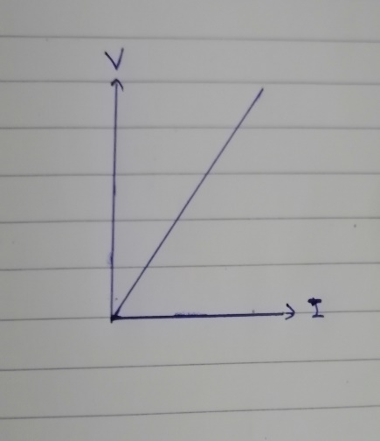 Slope= $\frac{∆V}{∆I}$=R
V=IR $→$ When the current direction from the positive electrode to the negative electrode is outside the electrical source
V= -IR $→$ When the current direction from the negative electrode to the positive electrode is outside the electrical source
- Law of Conservation of Energy

$\sum{POWER=0}$
∑$POWER SUPPLIED$ +∑$POWER ABSORBED$=0
Electrical power : The electric energy consumed within one second
P= IV The electric power is measured in watts (J/S)
- Kirchhoff's laws
- Kirchhoff's Current Law (KCL)
- Kirchhoff's Voltage Law (KVL)
Kirchhoff's Current Law: The sum of the electric currents entering at a point in a closed circuit is equal to the sum of the currents coming from it
∑ I=0 Kirchhoff's first law is an application of the Conservation Act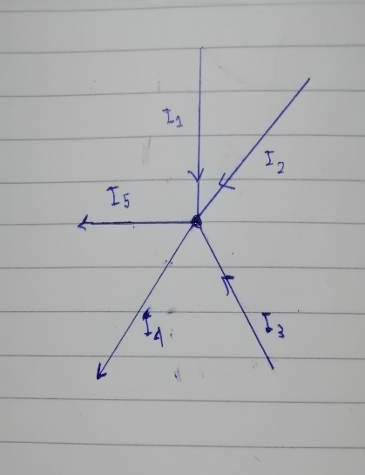 I1+I2+I3+(-I4 + -I5)=0
Kirchhoff's first law is used in circuits with branching and distribution points for current
Kirchhoff's Voltage Law: The algebraic sum of the electric driving forces in a closed circuit is equal to the algebraic sum of the voltage differences in the circuit
∑ V=0 Kirchhoff's second law is an application of the Energy Survival Act
Kirchhoff's second law applies to closed paths
A loop is a closed path formed by starting at a node , passing through a set of nodes , and returning to the starfing node without passing through any node more than once .
Node : A point where two or more circuit elements are connected .
A node is usually indicated by a dot in a circuit . If a short circuit connects two nodes , the two nodes constitute a single node
An electric current is required to have an electrical current connected to a closed circuit
Where the electrical current source: A flood of electrical charges goes through the conductors
The materials can be divided in terms of their electrical conductivity into :
- Conductive materials: It contains an abundance of free electrons to allow the passage of electrical current Like copper
- isolating materials: It does not contain an abundance of free electrons. Do not allow the passage of electrical current Like wood
- Semiconductors: Electrical conductivity materials medium between conductors and insulators Like silicon
Ideal basic elements of an electronic circuit
- Voltage(Potential difference)
When the voltage is two points on the conductor :
- Equal: No work is required to transfer charges between the two points and therefore no electrical current passes
- Various: a job is made to transfer charges between the two points and thus an electric current passes through
Potential difference(V) : The amount of work done to transfer an electrical quantity of 1 coulomb between the two points
V=$\begin{matrix}W \\ Q\end{matrix}$ ( W:energy , Q:charge )
The potential difference is measured in volts(V) ,( J/C)
The difference in voltage is measured by the voltmeter, and it is connected in parallel between the two points. The voltage difference between them is to be measured in the electrical circuit.
V=IR ( According to Ohm's Law )
$V_{12}$ > 0 means the potential of 1 is higher than potential of 2
$V_{12}$ < 0 means the potential of 1 is higher than potential of 2
$V_{12}$ =$V_{1}$ - $V_{2}$
Electrons flow from negative charges toward positive charges, while current flows from positive charges toward negative charges
That is, the direction of the current flow is the opposite of the direction of the flow of electrons
Electric driving force ($V_{B}$ ): The amount of total work done to transfer a 1 coulomb of electricity into and out of the column in the electrical circuit
Electric driving force of a source is measured in volts (V)
$V_{B}$ = IR + Ir
$↓$ $↓$ $↓$ Electric driving force external resistance internal resistance
- Electric current
Electric current : The amount of electrical charge passing through a section of conductor is estimated at a time of 1 second
I=$\frac{Q}{T}$ ( T: Time , Q : electrical charge )
N=$\frac{Q}{e}$ ( N: The number of electrons , e : Electron charge )
The electric current is measured in amps (A),(C/S)
The intensity of the electric current passing through a circuit is measured by the ammeter and is connected, respectively, to the circuit.
the electric current is directly proportional to the voltage according to Ohm's law
There are two types of currents :
- Direct current (DC): the movement of electric charge is unidirectional flow.
- Alternating Current (AC): the movement of electric charge periodically reverses the direction.
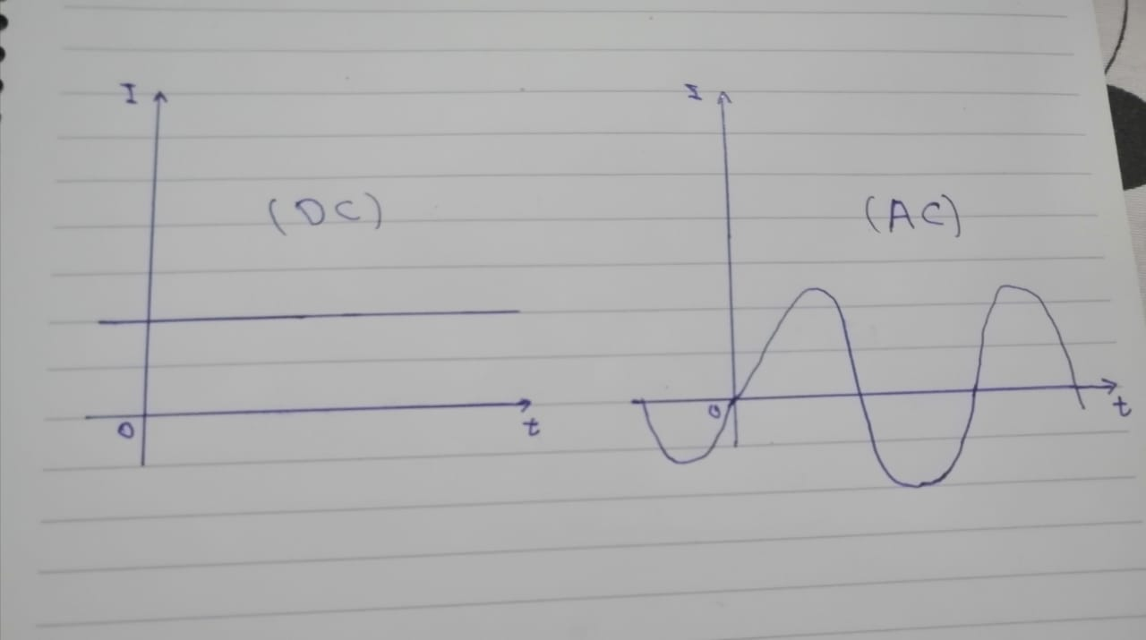
Alternating current (AC) can be converted to Direct current ( DC ) .
The alternating current is suitable in some operations such as lighting and heating.
The Direct current is suitable for other processes, electrolysis and electroplating.
Ameters are used to measure the intensity of a Direct current.
The hot wire ammeter is used to measure the alternating current and measure the Direct current intensity.
- Electric Resistance
Electric Resistance(R): Impedance the electric current passing through a conductor
There are two types of resistors: 1- Fixed resistance 2- Variable resistance
R=$\frac{V}{I}$ According to Ohm's Law(V=IR)
Electric Resistance(R): The ratio between the potential difference between the two ends of the conductor and the intensity of the current passing through it
Ohm's Law: When the temperature is established, the intensity of the current passing through a conductor is directly proportional to the difference in voltage between the two ends
The electric resistance is measured in ohms(Ω),(V/I)
R= $P_{e}$ $\frac{L}{A}$ ($P_{e}$: Specific resistance ; L: The length of the conductor , A: The area of ​​the conductor section)
The ohmmeter measures the electrical resistance.
The ohmmeter is connected to the terminal of the circuit whose resistance is to be measured.
Connect the resistors:
- Straight delivery
Purpose: Obtaining a large resistance from a group of small resistors where the equivalent resistance value is greater than the largest resistance in the group
The intensity of the current passing through each resistance is equal to the intensity of the passing current in the circuit I=I1=I2=I3
The total potential difference is equal to the sum of the voltage differences between the two ends of the resistors in the circuit V=V1+V2+V3
The equivalent resistance of a group of resistors equal their sum R=R1+R2+R3
- Parallel delivery
Purpose: Getting Small resistance from a group of large resistors
The total potential difference is equal to the voltage difference between the two ends of each resistance V=V1=V2=V3
The intensity of the total current passing through the circuit is equal to the sum of the intensity of the passing currents in the resistors I=I1+I2+I3
Equivalent resistance : $\frac{1}{R}$ =$\frac{1}{R1}+\frac{1}{R2}+\frac{1}{R3}$
- Electric capacitor
Electric capacitor: Two parallel metal plates with a dielectric between them and store electrical energy in the form of an electric field
the use: Storing electrical energy between its two panels as an electric field
Capacitor capacitance(C): The ratio between the accumulated charge on either capacitor plate and the potential difference between them
C=$\frac{Q}{V}$ ( Q: charge ; V: Voltage)
The capacitor capacitance is measured in units of farad (F),(C/V)
Connect the capacitors:
- Straight delivery
Equivalent capacitor: $\frac{1}{C}$ =$\frac{1}{C1}$ +$\frac{1}{ C2}$ + $\frac{1}{C3}$
- Parallel delivery
Equivalent capacitor: C=C1+C2+C3
Capacitors vary depending on the type of material used for insulation between the plates
Types of capacitors:
1- Capacitors with paper insulation. 2- Capacitors with plastic insulation
3- Capacitors with mica insulation. 4- Capacitors with ceramic insulation
There are three main factors that affect the capacitor's capacitance directly. These factors are:
1- Surface area of ​​capacitor panels 2- The distance between the panels.
3-Insulating medium
Capacitive reactance: The impedance received by the alternating current while passing through a circuit containing a capacitor due to its capacitance
- Inductors
Inductor: a conductive and insulated wire wrapped around itself in several turns. And when we connect the electrical current to it, this leads to the generation of a magnetic field that cuts the coils of the coil and surrounds it.
Magnetic induction: A phenomenon that generates an induced electric impulsive force as well as an induced electric current in a conductor in a closed circuit as a result of the change in the magnetic flux it cuts
emf=-N $\frac{∆∅m}{∆t}$ ( Faraday's Law of Magnetic Induction) (emf: Electric driving force , N: The number of file turns,$\frac{∆∅m}{∆t}$ : The rate at which the file cuts the flux lines)
Faraday's law: The induced electric impulse force generated in an electromagnetic induction coil is directly proportional to the time average at which the coil crosses the magnetic flux lines as well as the number of coil turns
The induced electric impulse generated in a coil can be increased by
1-increasing the number of coil turns 2- increasing magnetic permeability 3-increasing the relative speed between the coil and magnet
Mutual stimulation between two coils: the electromagnetic effect that occurs between two adjacent or interfering coils, one of which passes a variable-strength current, so the second is affected and a stimulated current is generated in it that resists the change in the first coil
Modulus of mutual induction between two coils(M): the amount of induced electric momentum generated in one of the two coils when the intensity of the other coil current changes at a rate of 1 ampere per second
M=$\frac{\left(emf\right)2}{∆I1/∆t}$ The coefficient of mutual induction is measured in units of Henry(H)
Self-induction of a coil : the electromagnetic effect that occurs in the same coil when the intensity of the current passing through it changes so that it resists this change
Coil induction Modulus: the amount of induced electric force generated between the two ends of the coil when the current intensity in it changes by 1 ampere per second
L=$\frac{µAN^{2}}{l}$ (µ: Modulus of magnetic permeability of the medium)
Applications on inductors: The generator ,electrical transformer and The electric motor
The role of semiconductors in the electronic revolution
Semiconductors: Solid materials with which the electric current passes with difficulty, whose electrical conductivity is controlled
The devices and equipment that are involved in its manufacture, semi-conductive materials are the basis of modern electronics, which includes radio, computer, telephone, television and many other devices. Semiconductor electronic parts include transistors, solar cells, diodes, light emitters and silicon-powered alternating current, and analog and digital integrated circuits.
Just as solar panels represent the largest example of semiconductor devices, they convert light energy into electrical energy.
In metallic conductors, electrons transfer electrical current, while in semiconductors, electrical current is transmitted by a flow of electrons going to the positive electrode, accompanied by a stream of holes during the atomic construction of the material going to the negative electrode. These positive electronic gaps help to suspend semiconducting material, such as germanium, with an impurity from another element.
Silicones are used to manufacture most commercial devices that contain semiconducting materials, and many other materials are used, including germanium, triple gallium arsenic, and silicon carbide. A pure semiconductor is known as a semiconductor. The conductivity is improved by adding an element or other elements called "impurities" by melting them and leaving them to cool to form a new crystal that is different from the original; this process is called the deformation process (adding impurities to a pure substance).
Semiconductors have many applications in the electronics industry for their various functions. These include Integrated Circuits, Microprocessor and Microcontroller, among others. It is considered one of the basic tools in the electronics industry.
And it is currently receiving a great interest in the field of using solar rays to generate electric energy by photovoltaic panels and photovoltaic cells.
It is also used as meters and detectors to measure X-rays, gamma rays and alternatives to the Jaeger counter and primary particle counters used in elementary particle physics.
Due to the high technology in its production, it is the sensitive part of digital cameras, where several million of them can be made in 1 square centimeter. Scientists were able to exploit it in computers, mobile phones, and GPS devices. The kind produced for light is used in billboards.

Conclusion

- Using electronics today is so much a part of our daily lives we hardly think of the way the world would be without electronics.
- Electronics is the art of controlling the movement of electrons in order to design components and circuits that are put together to create the technology of the modern world.
- Basic laws of electricity and methods used in circuit analysis are Ohm's Law, Law of Conservation of Energy and Kirchhoff's laws
- Ideal basic elements of an electronic circuit are Voltage, Electric current , Electric Resistance .Electric capacitor and Inductors
- The role of semiconductors in the electronic revolution is great

References

[ 1 ] Nilsson J. W. Reidel S. Electric Circuits. 10th Edition, Prentice Hall. (2014).
[ 2 ] Charles K. A Matthew N. S. Fundamentals of electric circuits, 5th Edition, Mc Graw Hill, (2013).
[ 3 ] https: // en. wikipedia. org / wiki / Electronics
[ 4 ] https: // learn. sparkfun. com / tutorials / analog -vs- digital / all
[ 5 ] https: // circuitglobe. com / electrical -resistance. html
[ 6 ] http: / / resistorselect. blogspot. com /
[ 7 ]https://WWW .electronics – Tutorials. ws / dccircuits / dcp 4. html
[ 8 ] https://WWW .youtube.com/watch?v=Ob1v-wh7EGU
[ 9 ] http://Www.ekb.eg.
[ 10 ] http://bubl.ac.uk
[ 11 ] http://www.oclc.org
[ 12 ] http://www.dogpile.com

References

[1] | Alred, G.J., Brusaw, C.T. & Oliu, W.E. Handbook of Technical Writing. Bedford/St. Martin's, 2006.
[2] | Al-Naim M. & Al-Mudara N. Electronic Court. King Faisal University College of Computer Sciences and Information Technology, 2012.
[3-5] | Bond, J. K. (2012). Advanced Programming in Java. (2nd ed.). New York: ABC Publishing Company.
[6] | Bond, J. K. & Lang, A. (2012). Action Script 3. (2nd ed.). New York: ABC Publishing Company.
[7] | Al-Arfaj, H. (2009). The Neural Networks in Motion. Retrieved from http://books.google.com
[8] | Al-Eid, A. (2012). The Changes in GUI. Journal of Computer Explosion, 27(10), 1327-33.
[9] | Regal, R. (2012, April 7). Globalizing Variables. KFU News. Retrieved from http://www.kfu.news.sa
[10] | Snippets in C#. (2010). San Diego: ABC Press.
[11] | Plagiarism. (n.d.). In Wikipedia. Retrieved January 10, 2013, from http://en.wikipedia.org/wiki/Plagiarism
[12] | Rosario, R. (2008, April 7). Personal interview.
[13] | Sebastian, B. (2010, July 25). Programming Style. PCPrograms.com. Retrieved July 25, 2010, from http://www.pcprograms.com.
[14] | Al-Mulhem, K. (2009). Delphi Guide [Online Video]. Delphi Videos. Retrieved from http://www.youtube.com/watch?v=asd5thw.

